Aggregation Index

To address the landscape heterogeneity of studied cities, we selected four metrics, namely Percent Land (PLAND), Shannon’S Diversity Index (SHDI), Fractal Dimension Index (FRAC), and Aggregation Index (AI). The selection of these metrics comes from a comprehensive quantification of both composition (PLAND, SHDI) and spatial configuration (AI, FRAC) of landscape patterns (Alberti, 2008). Through initial regression models, Aggregation Index has exhibited strong significance in all specifications, and was therefore chosen as the primary indicator to represent urban spatial characteristics. It equals the number of like adjacencies involving the corresponding class, divided by the maximum possible number of like adjacencies involving the corresponding class, which is achieved when the class is maximally clumped into a single, compact patch, multiplied the proportion of the landscape comprised of the corresponding class, summed over all classes (McGarigal and Marks, 1995). The mathematical expression is

(100)

in which denotes the number of like adjacencies (joins) between pixels of patch type (class), i based on the single-count method. denots maximum number of like adjacencies (joins) between pixels of patch type (class). denotes proportion of landscape comprised of patch type (class) i.

As Aggregation Index is able to measure the dispersion of a certain landscape class towards to multiple landscape classes (He et al., 2000; Alberti, 2008), we refined the measurement of impervious surface into four categories defined by NLCD, namely developed land of high intensity, medium intensity, low intensity, and open space. Under the same window, aggregation indices could be notably different based on refined classification, as opposed to a combined type of urban land. To manifest such differences, we used three slices in San Francisco as an example (Figure 1). The example hires a 10 x10 window, which is 300 x 300 meter in reality. The first window is set at the southeast edge of financial district, close to San Francisco shoreline and Rincon Hill. Second window is drawn at a high density residential neighborhood called Cathedral Hill, 2.4 miles from the Financial District. The third is drawn at Forest Hill, 7 miles from the Financial District, which is a typical low density residential neighborhood, with a higher percentage of open space and green area. It could be seen that at places of 100% urban land, Cathedral Hill and Financial District, aggregation indices vary accordingly. Later we applied same measuring methods for 27 cities.

Citations (in MLA format):

1. Alberti, Marina. Advances in urban ecology, integrating humans and ecological processes in urban ecosystems. No. 574.5268 A4. 2008.

2. McGarigal, Kevin, and Barbara J. Marks. "Spatial pattern analysis program for quantifying landscape structure." Gen. Tech. Rep. PNW-GTR-351. US Department of Agriculture, Forest Service, Pacific Northwest Research Station (1995).

3. He, Hong S., Barry E. DeZonia, and David J. Mladenoff. "An aggregation index (AI) to quantify spatial patterns of landscapes." Landscape Ecology 15.7 (2000): 591-601.

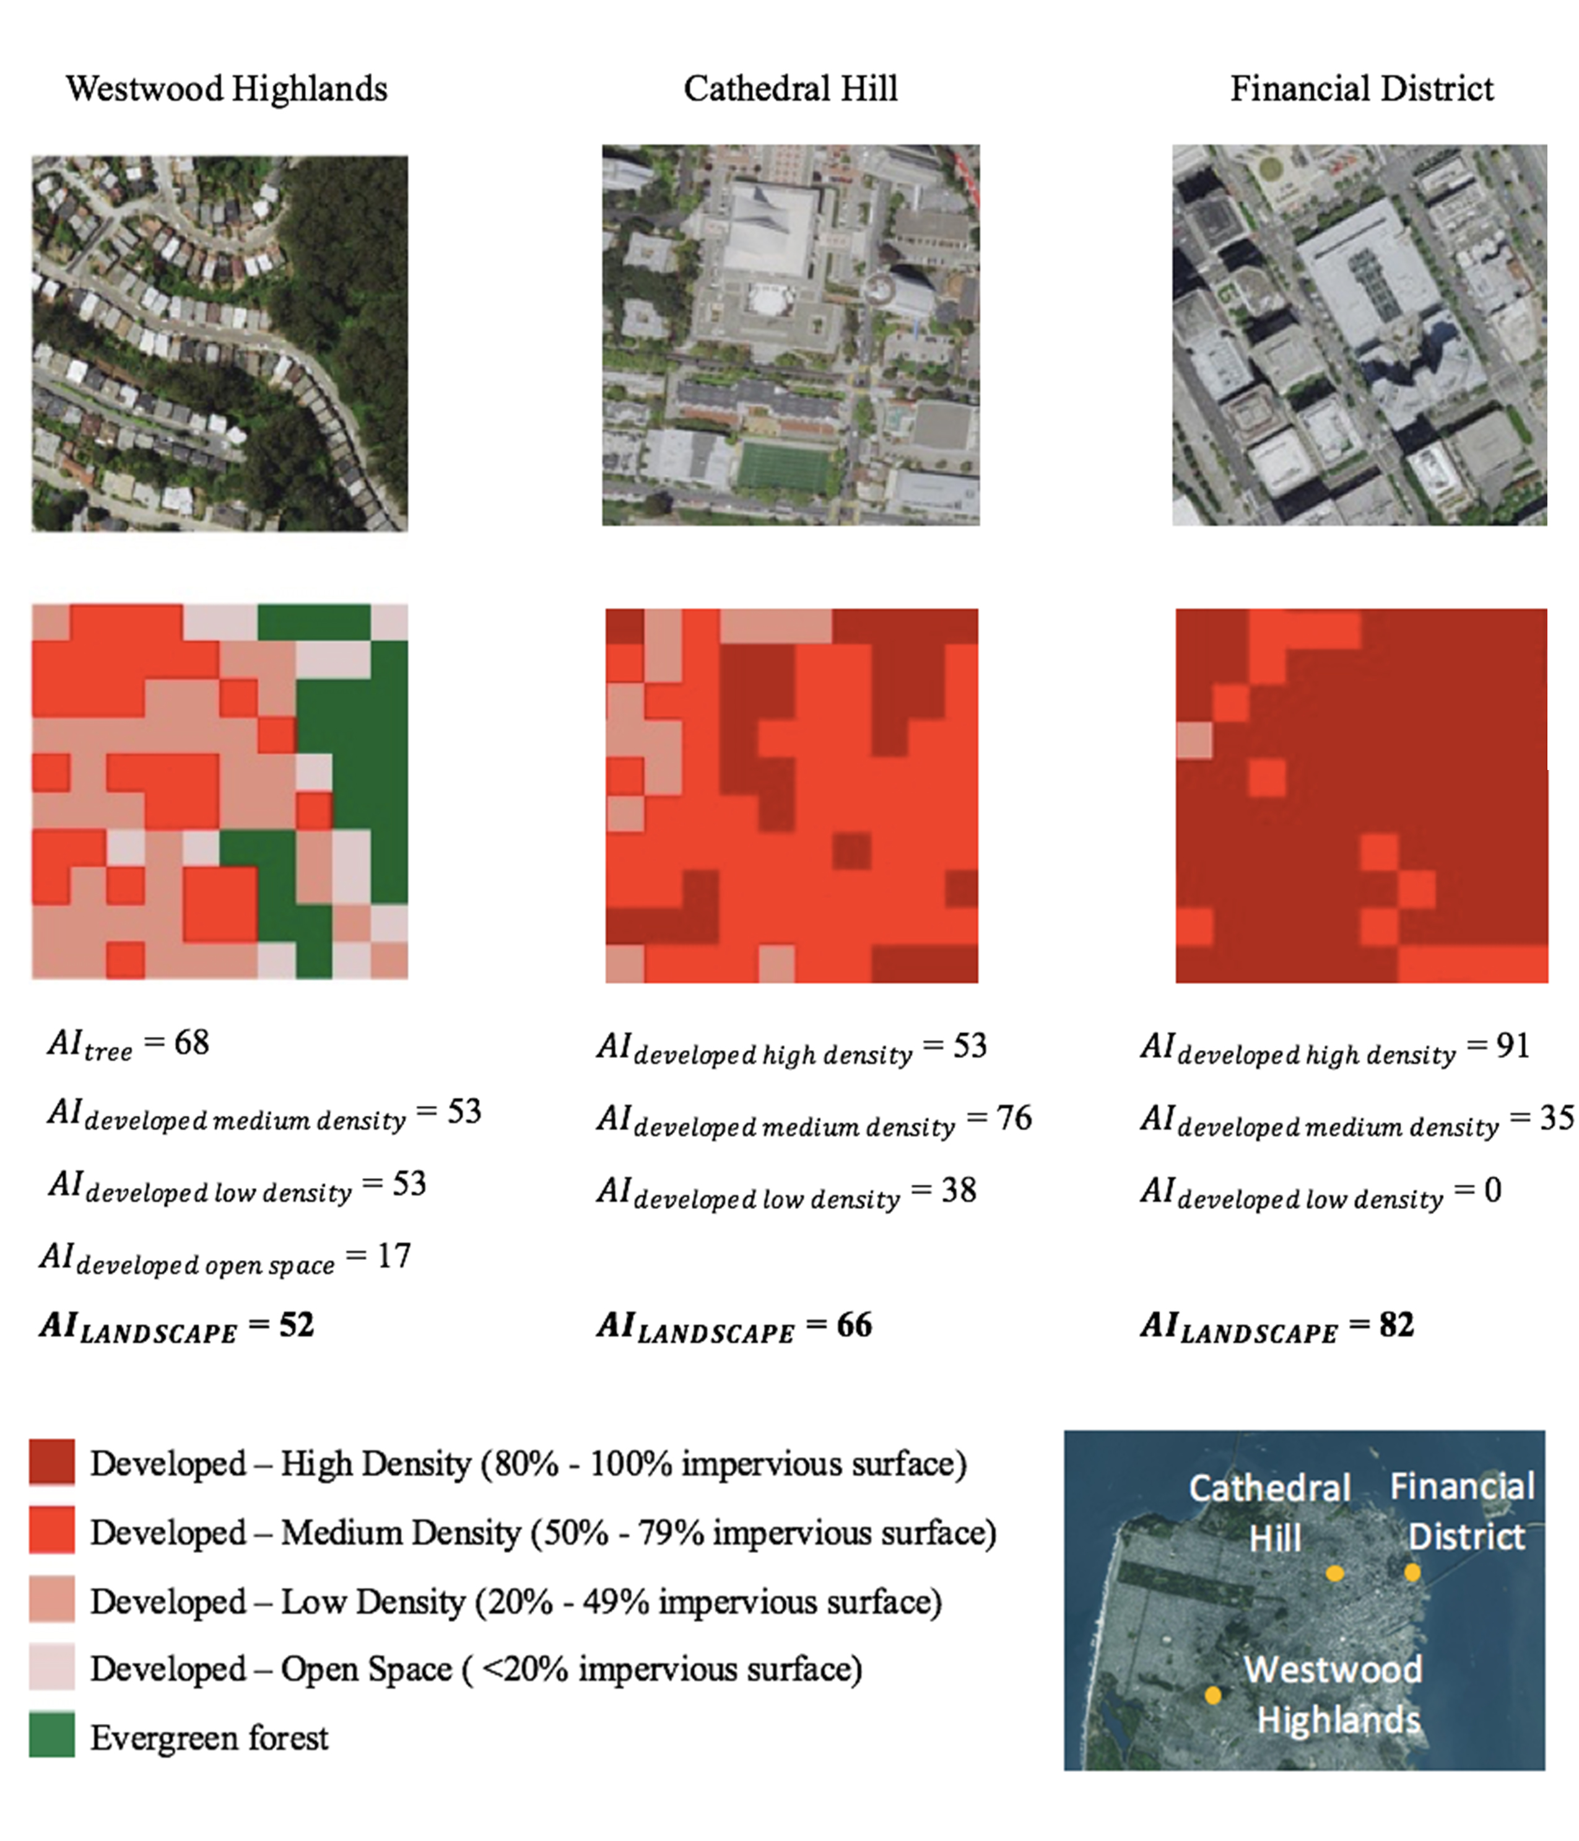

Figure 1. Aggregation Index of Refined Categories of Urban Land, San Francisco